Water management practices, bioindicators and modeling ecosystem restoration.
P. Rehage and L. Collado-Vides

Essential Questions:
How do human activities impact ecosystem dynamics of the coastal community in Biscayne Bay, Florida?
How do ecologists use bioindicators to evaluate ecosystem health?
How do ecologists use theoretical models to help guide restoration strategies?

Grades: 9-12
Time/Duration : 1-1.5 hours to introduce activity, facilitate class discussion, model procedure and support students through activity.

Subject: Ecology, Marine Science, Environmental Science, Biology
Next Generation Science Standards:
HS-LS2. A Interdependent Relationships in Ecosystems
Disciplinary Core Ideas
Ecosystems have carrying capacities resulting from biotic and abiotic factors.
The fundamental tension between resource availability and organism populations
affects the abundance of species in any given ecosystem.

HS-LS2.B Cycles of matter and energy transfer in ecosystems
Disciplinary Core Ideas
Photosynthesis and cellular respiration provide most of the energy for life processes. Only a fraction of matter consumed at the lower level of a food web is transferred up, resulting in fewer organisms at higher levels. At each link in an ecosystem elements are combined in different ways and matter and energy are conserved. Photosynthesis and cellular respiration are key components of the global carbon cycle.

HS-LS2.C Ecosystem dynamics, functioning, and resilience
Disciplinary Core Ideas
If a biological or physical disturbance to an ecosystem occurs, including one induced by human activity, the ecosystem may return to its more or less original state or become a very different ecosystem, depending on the complex set of interactions within the ecosystem.

Target Learning Objectives/ Concepts/ Desired Results:
1. Students construct knowledge using technology
2. Students construct knowledge of cause and effect relationships by graphing data.
3. Students apply ecological theory to evaluate graphed data.
4. Students apply ecological theory to predict the outcome of different restoration strategies.
5. Students will conclude that human activities may impact ecosystem dynamics, functioning and resilience.
6. Students will learn that bioindicators can be used as an ecosystem assessment tool.
Skills:
1. Graphing, analyzing and interpreting data.
2. Given a hypothetical circumstance, apply data to predict outcome
3. Critical thinking-
Prior Knowledge:
Students know that abiotic and biotic factors can influence the ecology of organisms.
Human activities can alter the community composition of an ecosystem
Salinity and nutrients are abiotic factors.

Activities Overview
You will browse the Florida Coastal Everglades Long Term Ecological Research site, and Google Earth to become acquainted with the Everglades watershed and Biscayne bay. Then, you will use ecological field data to learn how nutrient rich freshwater input from a nearby water management structure impacts submerged aquatic vegetation and the overall health of the nearshore community in Biscayne Bay, Florida. You will gain the perspective of an ecologist by using some of the same tools to investigate the cause and effect relationships between salinity, nutrients and the community composition and distribution of submerged aquatic vegetation. First, you will calculate and plot species diversity of three different sites and then you will interpret data to generate simple theoretical models to guide your direction to restore Biscayne Bay’s nearshore ecosystem. In addition to the data that will be provided for you, you will be encouraged to visit many websites to gain a deeper understanding of the conceptual nature of the real world problem that you will help solve.

Activity 1: Visit http://fcelter.fiu.edu and Google Earth
Activity 2: Plot temperature and salinity variation
Activity 3: Determine species richness of Macroalgae across
Activity 4: Annotate Study Site Map
Activity 5: Use simple flowcharts to model outcomes
Activity 6: Determine Species Richness
Activity 7: Interpret Graph
Activity 8: Use Hypothetical Models to Predict Outcomes

Background
Earth’s global ecosystem produces and sustains the conditions necessary for life. The health of Earth’s local ecosystems determine the health of the global ecosystem. Ecosystem stability, regulated by natural feedback loops may be altered by human activities and may compromise life sustaining ecosystem services. The Everglades watershed defines south Florida’s natural landscape, and provides water for human consumption, agriculture and seafood for its inhabitants. The Florida Coastal Everglades region, like many coastal ecosystems around the world, has been influenced by natural and human disturbances (Orth et al. 2006, Bruno et al. 2009). Coastal and watershed development are linked to the decline of habitat health and decreased resource production ( Lapointe et al. 2004, 2007, Orth et al. 2006, Kleypas and Eakin 2007, Halpern 2008, Duarte et al. 2009 ). The activities of six million people in the south Florida metropolitan area has intensified the vulnerability of the Everglades watershed to human impact (Meeder and Boyle 2001, Lapointe and Barile 2004, and Carnahan et al. 2008, 2009).
The Biscayne Bay ecosystem shows increasing signs of distress; declines in fisheries, increased pollution, and dramatic changes in nearshore vegetation. Northern and central Biscayne Bay are strongly affected by the urban development associated with the growth of Miami. Southern Biscayne Bay is influenced by drainage from the Everglades, which has been altered by canals and agricultural activities. Restoration and preservation of Biscayne Bay and Biscayne National Park are dependent on a comprehensive understanding of the linkages between the hydrologic system and the bay ecosystem, and of the natural versus human-induced variability of the ecosystem (Ishman 2006).

A comprehensive restoration effort has been initiated to reverse the damage. Planners are collaborating with scientists to restore the natural hydrology to Biscayne Bay in south Florida. The Comprehensive Everglades Restoration Plan (CERP) lists restoration of the timing, quantity, and quality of the natural flow of freshwater as one of its primary goals.
The scientists contribute their findings to create theoretical models which are then used to predict restoration outcomes and guide the restoration strategy. One way for ecologists to understand how hydrology impacts an ecosystem, is through the use bioindicators. Submerged aquatic vegetation communities, common in Biscayne Bay can be used as bioindicators to learn how the nearshore community exposed to fluctuating salinity and nutrients can be expected to change (Lapointe et al. 1994).
References
Biber P.D., Irlandi, E.I., 2006. Temporal and spatial dynamics of macroalgal communities along an anthropogenic salinity gradient in Biscayne Bay (FLorida, USA) Aquatic Botany 85 (2006) 65-77.

Collada-Vides, L., Mazzei, V., Thyberg, T., Lirman, D., 2011. Spatio-temporal patterns and nutrient status of macroalgae in a heavily managed region of Biscayne Bay, Florida, USA. Botanica Marina 54 (2011) : 377-390.

Lin, D.T., Fong, P., 2008. Macroalgal bioindicators (growth, tissue N, 15N) detect nutrient enrichment from shrimp farm effluent entering Opunohu Bay, Moorea, French Polynesia. Marine Pollution Bulletin 56 (2008) 245-249.

Fletcher, P.J., Kruczynski, W.L. Editors. 2012. Tropical Connections, South Florida’s marine environment. IAN Press. Cambridge, Maryland.

Ishman, Scott, 2006, Ecosystem History of Biscayne Bay and the Southeast Coast.
South Florida Information Access (SOFIA)

Next Generation Science Standards website
nextgenscience.org

Activity 1:
Florida Coastal Everglades Long Term Ecological Research website http://fcelter.fiu.edu.
Find the FCE LTER Interactive Everglades Map by first clicking Data tab - FCE LTER Data Products - GIS Data and Maps and finally the Interactive Everglades Map.

Find the layers on the left side of the map, check canals, and then click on the map. The canals layer will appear on the map. Follow and note the network of canals directing the flow of water into Lake Okeechobee from the north and out to the east, west, and south to the Everglades and Biscayne bay.

Click the Everglades National Park Boundary, click the map once more and then print your map to use as a reference. If you don’t have access to a color printer, you may want to highlight or color the major features of the map.

Activity 2:
Water’s Journey Everglades
http://www.theevergladesstory.org/animation/
Once you arrive to the above website, watch and answer the questions for each clip.

Lake Okeechobee and Phosphorus
What is the relationship between rainwater and pollution?

How does stormwater runoff impact lake Okeechobee, coastal estuaries, and the Everglades?

Under what circumstances is contaminated water released from lake Okeechobee into coastal estuaries?

How might an input of nutrient rich water impact an estuarine ecosystem?

What is the goal of the Everglades restoration plan?

Kissimmee

What is the link between the Kissimmee river lake Okeechobee, and the Everglades?

Why was the Kissimmee river channelized?

Stormwater Treatment

Describe how nutrient rich water from agricultural areas is cleansed before it flows into the Everglades.

The Changing Everglades

Compare the Everglades historical hydrology to present day hydrology.

Which human activities have led to present day hydrology?

Activity 3:
Google Earth
To get started, open Google Earth on your computer.
Enter Biscayne Bay, Florida in the search box.
Go to view and check “Grid” to see the latitude and longitude.

Find W 80º19’30” and N 25º 32’6”.

Biscayne bay is affected by drainage through water control structures from urban areas and the Everglades. To increase your understanding of the relationship between human activities and Biscayne bay’s ecosystem, answer the questions below.

The structure at W 80º19’30” and N 25º 32’6” is a freshwater canal. Follow the canal in a northern direction and note the land use along its path. Where does this canal begin?

What is the latitude and longitude of Miami, Florida?

Explain How land use impacts the water quality in the canal.

Apply what you learned about stormwater runoff to formulate a hypothesis about how variation in temperature, salinity, and an increase in nutrients might impact the nearshore ecosystem of Biscayne bay.

Design an experiment to test your hypothesis.

Activity 4: Annotate Study Site Map

A team of scientists designed an experiment to test how variation in water temperature, salinity, and nutrients impact the nearshore community in Biscayne bay. Recall what you learned during each activity and predict what the scientists learned through their investigation.
You may recognize the study site from the Google Earth activity.

Enhance your map by following the steps below.

Draw a compass rose with cardinal( N,E,S,and W) and intermediate directions (NE,SE,SW,and NW).

Use the compass rose you drew to indicate the direction and distance to Miami, lake Okeechobee, the everglades and your home town.

Color code the study sites and data loggers on the map

Study Sites and Data Loggers | Color Code
Marine | Red
North | Orange
South | Yellow
Sal 6 | Green
Sal 7 | Blue
Sal 8 | Indigo
Sal10 | Violet

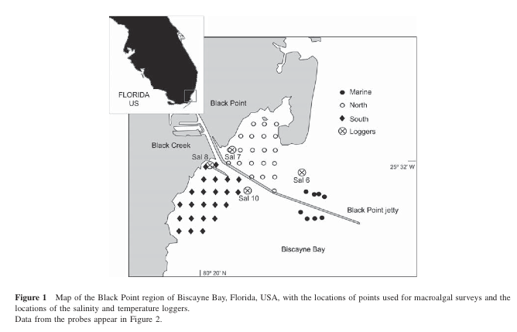

Activity 5: Plot Salinity and Temperature Variability

The data in the table below is the median water temperature and salinity from all north and south sites.

Plot the median and the range (using bars ) for the north and south sites for temperature and salinity using the graphs provided.

Salinity and Temperature variability
Site | Median Temperature ( C) | Range ( C) | Median Salinity | Range
North | 23 C | 22 - 29 | 25 | 33 - 19
South | 28 C | 16 - 36 | 19.5 | 3 - 33

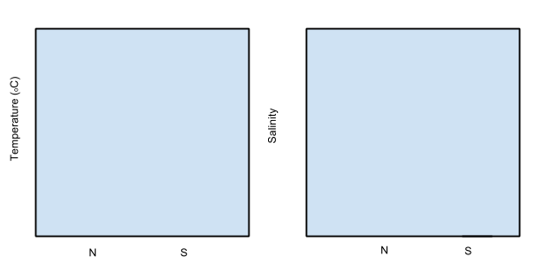

Activity 6: Determine Species Richness

Species richness is used to compare the number of species at each site as an indicator of water quality.
Determine the species richness at different sampling sites using the presence absence data
from Table 1. Species list by phylum

Sampling Site | North | South | Marine | Dry | Wet
Number of Species
Dominant Species
Site Characteristics

Number of Species of Macroalgae vs Sampling Site in Biscayne Bay

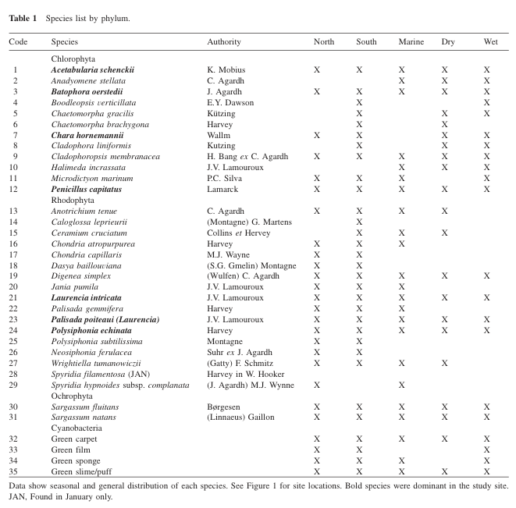

Activity 7: Interpret Graph

Use the graph below to model the impacts of water flowing into Biscayne bay
from the Blackpoint canal.

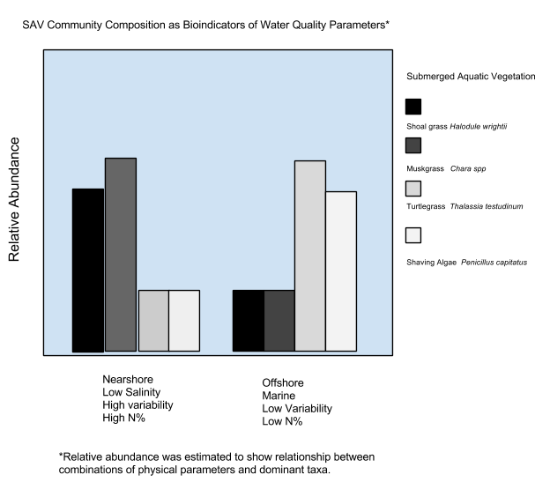

Activity 8: Use Hypothetical Models to Predict Outcomes
New Generation Objective: Students use models to show relationships between community composition and fluctuations in salinity, temperature and nutrient dynamics in a managed area.

Modeling SAV composition in response to physical changes.

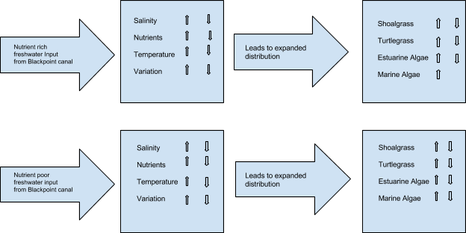

Consider an alternative to the above two scenarios, and then construct a hypothetical model to predict the outcome.

Discuss your hypothetical model. Explain your rationale for your predicted outcomes.

Create a six-frame comic strip to summarize what you have learned about ecosystem dynamics, human impact, bioindicators and restoration.

